**EXCEL PROJECT REPORT**

**TOPIC: AI JOB MARKET INSIGHTS**

*NAME: NEELANJAN DUTTA*

*REGISTER NUMBER: 2448040*

*SUBJECT NAME: APPLIED EXCEL*

*SUBJECT CODE: MDS151*

**INTRODUCTION**

The project gives an in-depth analysis of the AI job market, from how a number of industries, ranging from Technology to Healthcare and beyond, into Finance, are recording consistently high demands for AI ability. It also points out the main trends related to global job opportunities, competitive salaries, automation risks, and the need for upskilling in order to be relevant. Positive projections on how AI is going to power job growth are driven by an ever-increasing role AI is playing in business innovation and operations.

**SIGNIFICANCE**

The "AI Job Market Insights" project will be important for understanding the influence of AI on the labor market. It finds emerging trends, underlines in-demand skills, and analyzes market dynamics and salary insights. This project shall help job seekers, employers, and educators realign with the industry's needs to cope with the rapid evolution of technology.

**CONTEXT**

In the face of rapid technological innovation, the "AI Job Market Insights" project investigates transformative effects within industries arising from AI. This research into job postings, educational alignment, and economic impacts could be most informative for job seekers, employers, policymakers, and educators alike. This project enables various stakeholders to effectively navigate this AI-driven job market to remain prepared for upcoming opportunities and challenges.

**DATA DESCRIPTION**

The attached file is in CSV format and contains ai_job_market_insights for different job roles across various countries. The dataset consists of 500 rows and 10 columns of data, which represent 500 job roles across different countries. Below is the explanation of each columns in the data set:

1. **Job Title**: The title of the AI job.
2. **Industry**: The industry to which the job belongs.
3. **Company Size**: The size of the company (Small, Medium, Large).
4. **Location**: Geographical location of the job.
5. **AI Adoption Level**: The three-tiered level of AI adoption in the company for which this job posting is meant to recruit new employees or workers. It can be categorized into three sections, namely Low, Medium, High
6. **Automation Risk**: This is the risk level associated with automating the working role. Automation risk for the job can be defined as Low, Medium, High.
7. **Required Skills**: The primary skills required for the job.
8. **Salary USD**: The salary for which the job will be offered.
9. **Remote Friendly**: Whether the job is remote-friendly or not.
10. **Job Growth Projection**: Projection of growth for this type of job.

**OBJECTIVE**

The jobs related to AI, the status of adoption and automation risk by industry, and within a given industry, the demand of certain skills are all integral parts of this project. This project will also study trends in salaries for different job roles across various industries and locations, as well as look into job growth projections and remote-friendly opportunities in the AI job market.

**Data Collection:**

The data for this project is sourced from Kaggle. These sources comprehensively view AI-related job postings, including job titles, locations, needed qualifications, and salary information. Data is collected periodically to capture the latest trends and dynamics in the job market.

**METHODOLOGY**

**1. Data Import and Cleaning:**

**Data Importing**

First, launch Excel and select the "Data" tab on the Ribbon to import data into Microsoft Excel. Next, choose the import option according to the source of the data: "From Text/CSV," "From Web," "From Access," or "Get External Data." Then, after having done that, browse and locate the data file that you want to import. Having selected the file, you have to set the import parameters: for CSV, you have to select the type of delimiter; for other formats, it is necessary to choose the data type for each column or the date format. Click "Load" to load the data into the worksheet.

**Data Cleaning:**

In column H, find that all the numbers are **not** in the **same format**.

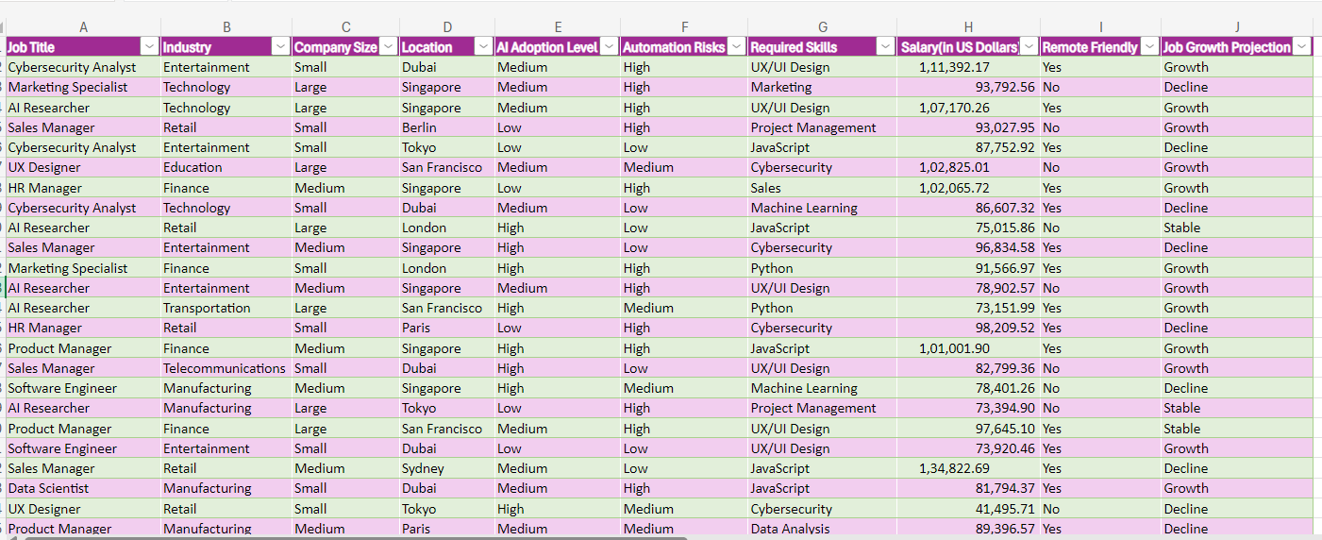

Basically, what we need to do is clean up the data to make sure all the numbers are properly aligned and formatted. This involves cleaning leading or trailing spaces, making sure all entries are in numeric format, appropriately treating non-numeric entries, and having formatting consistent across the column. The cleaned modified data set is given by:

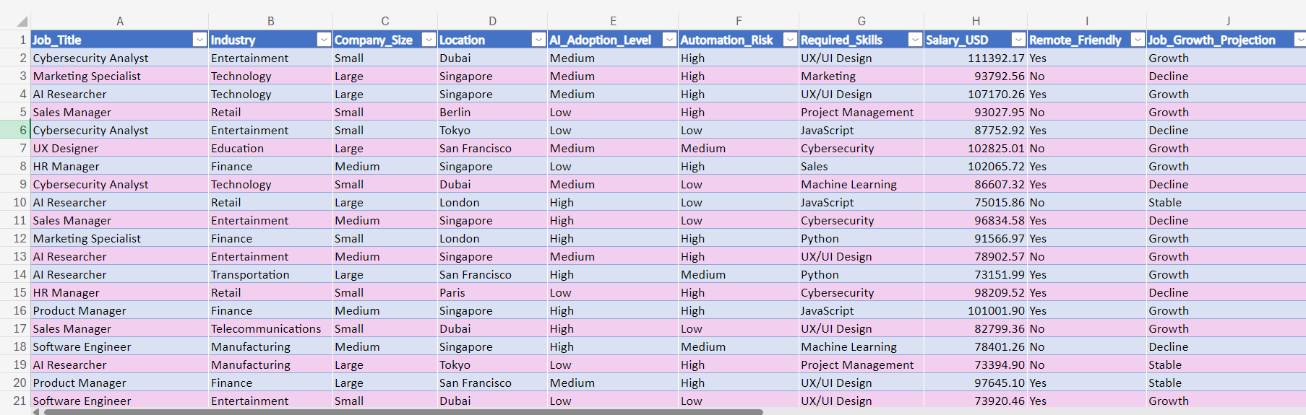

**2. Data Validation**

Validation is the next step in this process. Data validation can be defined as the process of going through the data once more in an attempt to ensure that such data meets any stipulated standards concerning accuracy, consistency, and completeness. You check at this stage that the data is correctly formatted without errors and ready for analysis.

In column H, the data has been cleaned, but it is still not in the right format. The salary column is currently displayed in an accounting format, including currency symbols and commas.

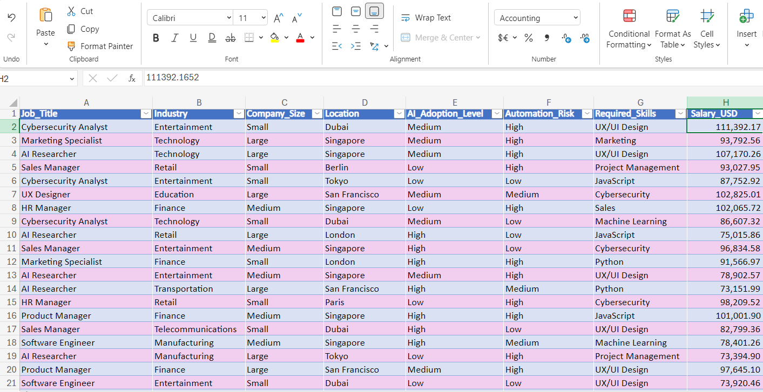

For this, the values needed to be converted into a simple numerical format that could be used appropriately for analysis by changing the format. The format changed is herein presented.

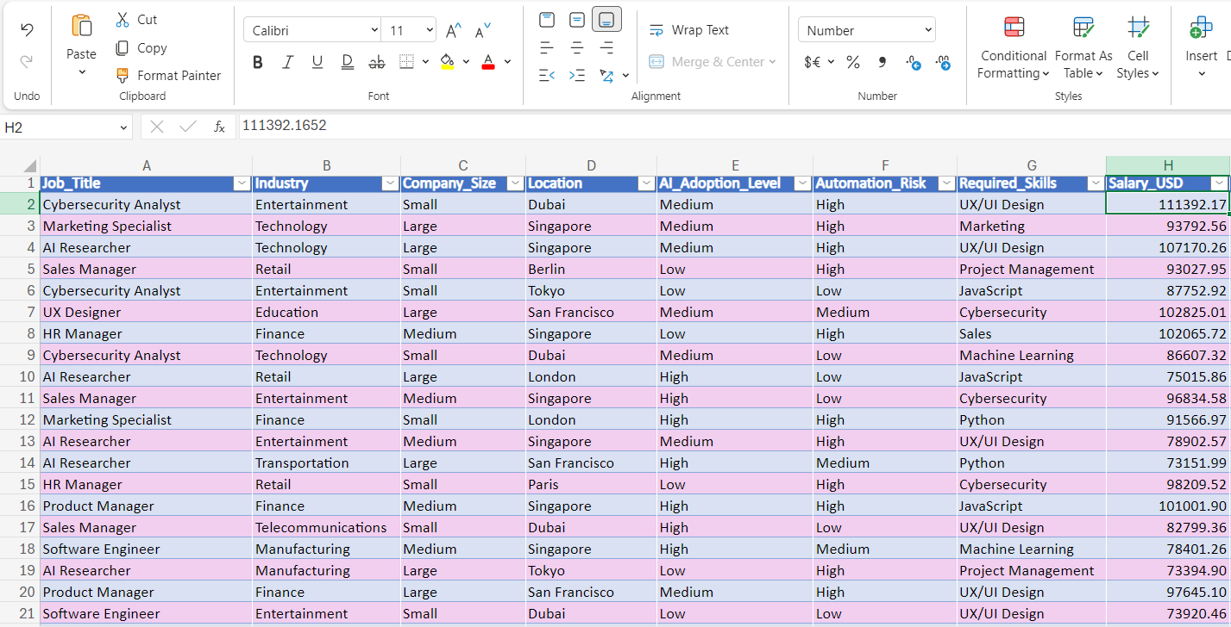

**3. SUMMARY STATISTICS**

**DESCRIPTIVE ANALYSIS**

Here, the **total salary** in all the departments taken together is $ 45611195.49

The **mean salary** is $ 91222.39; the **median salary** is $ 91998.20; the **maximum salary** is $ 155209.82, while the **minimum salary** is $ 31969.53. The below table portrays the above-mentioned values.

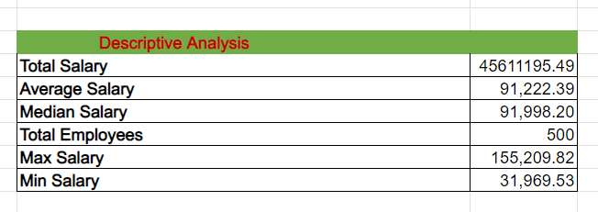

The functions used in this example are **SUM, AVERAGE, MEDIAN, COUNTA, MAX,** and **MIN**

**SOME MORE ANALYSIS:**

**The following table shows some analysis of various jobs along with their locations and industries.**

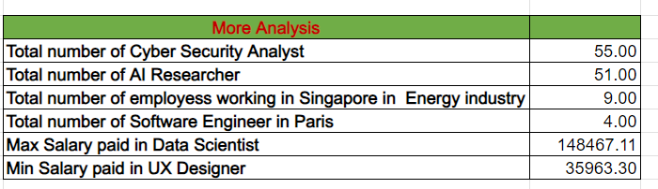

Formulas used in this problem is  **COUNTIF, COUNTIFS, MAXIFS, MINIFS.**

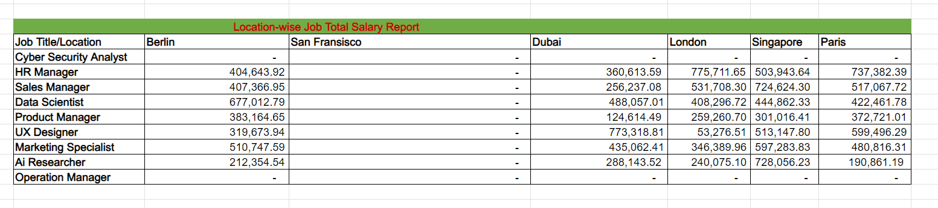

The formulas applied hereis **SUMIFS**

**DATA ANALYSIS:**

**Broader Job Role Analysis:**

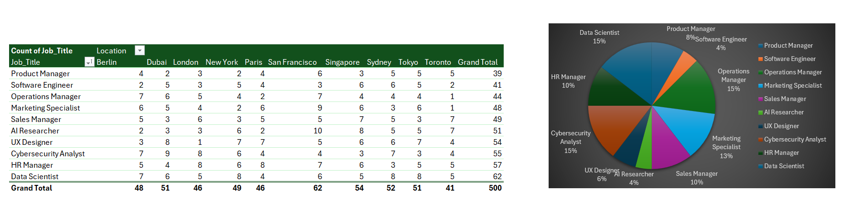

**Interpretation:**

1. The overall count for the **Data Scientist** role is the **highest**, at **62**, which is highly in demand in locations.

**2.** The important presence of **HR Manager** at **57** and **Cybersecurity Analyst** at **55** exists within the cities

3. **Product Manager** has the **lowest** overall count of **39**.

4. **San Francisco** has the highest total number of job roles posted, at **62**, followed by **Sydney** at **54** and **Singapore** at **52**, which may indicate that these cities are the major hubs for these job roles

5.  **New York**, **London**, and **Paris** had quite a balanced distribution of the roles; hence, diversified job markets for almost all sectors.

6. **Dubai** was particular in its focus on **Cybersecurity Analyst**-**9** roles and **Operations** **Manager**-**7** roles, which could mean regional concerns regarding security and effective operation

7. **Berlin** represents a somewhat lower overall count at **48** roles but shows particular focus on both **Operations Manager** with **7** roles opened and **Data Scientist** with **7** roles, underlining a strong operational and analytical need in the city.

**AI Adoption Risks:**

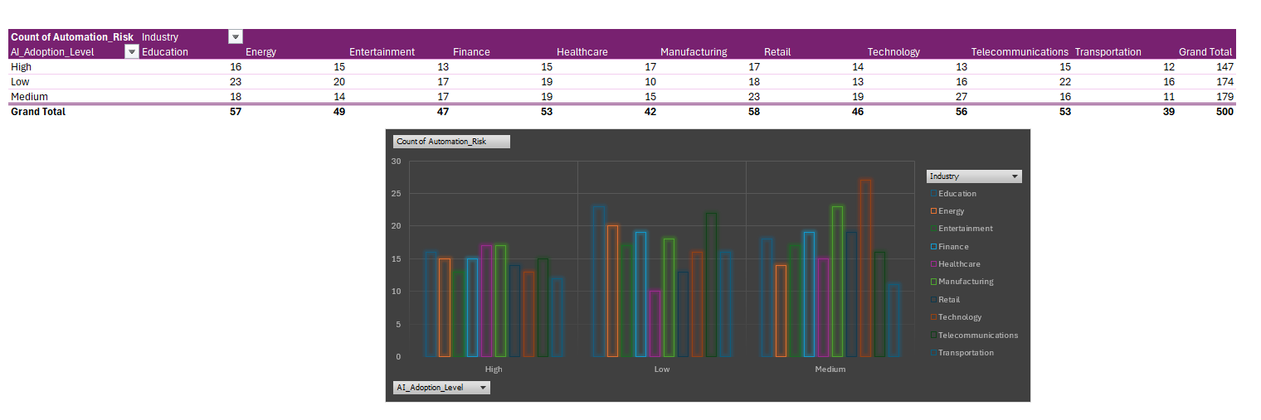

**Interpretation:**

1. **Automation Risk Levels by Industry:**
   * **High Risk:**

**Transportation** leads with a count of **7, Technology 5,** and **Education 3.**

* + **Low Risk:**

**Transportation (6)** and **Education (9)**

* + **Medium Risk:**

**Transportation (12)** and **Technology (8)**.

1. **Industries with Highest and Lowest Automation Risk:**

**Transportation** has the highest counts at all risk levels and, in particular, at a **medium** level.

**Education** is **high** on both the **low (9)** and **medium** level **5**.

1. **Comparison of AI Adoption Levels:**

**The industries differ in the distribution of AI adoption levels, namely high, low, and medium.**

**High** risks of AI adoption is more prominent in **Transportation**, followed by **Technology**.

**Transportation** and **Technology** are quite **prominent** in automation risks, which could be one probable area of concentration for automation and implementation of AI, while **Education** has variability across the **low** and **medium** levels of risk.

**Skill Demand Analysis:**

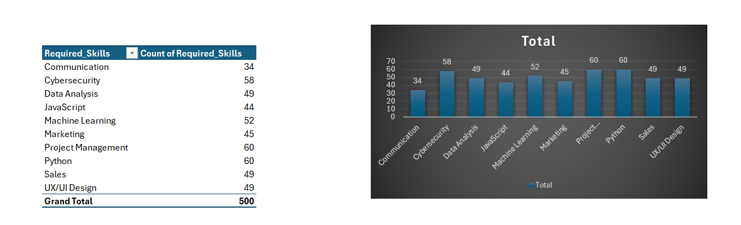

**Interpretation:**

The table and bar chart in this presentation show some of the most in-demand skills in today's job market by portraying which abilities are being highly sought after in many positions:

1. **The Most In-demand Skills:**
   * **Python** ,60 mentions: The most crucial skill required for programming, data science, and automation
   * **Cybersecurity**: With 58 mentions; this could be due to the ever-growing need for digital protection in today's increasingly online world.
   * **Machine Learning** ranks third with **52** mentions, showing that it is essential to further artificial intelligence and data-driven decision-making.
2. **Comptencies in Constant Demand:**
   * **Data Analysis**, **Sales**, **UX/UI Design**, with each having **49** mentions, along with **Project Management** at **60** mentions, are also in high demand. This shows the importance of each of these skills across a wide array of industries.
   * **JavaScript** has received **44** mentions, while **Marketing** has received **45** mentions. These skills are still quite relevant but perhaps especially in positions requiring both **technical knowledge** and creative and **strategic thinking.**
3. **Skills Mentioned Less Frequently**:
   * **Communication** occurs the least, appearing **34** times. That could hint that it is so core that it calls out not very often directly or explicitly.

Python, Cybersecurity, and Machine Learning are among technical high-demanding skills. This trend shows a surge in the role of technology and data proficiency in the contemporary labor market.

A combination of skills relating to technical, analytical, and managerial capabilities, such as Data Analysis, Sales, UX/UI Design, and Project Management, are also in high demand and show the necessity for professionals with many different facets.

Though Communication is not as highly listed, it is nonetheless a very important skill and, it would seem, an assumed basis for most positions.

**Salary Trend Analysis**

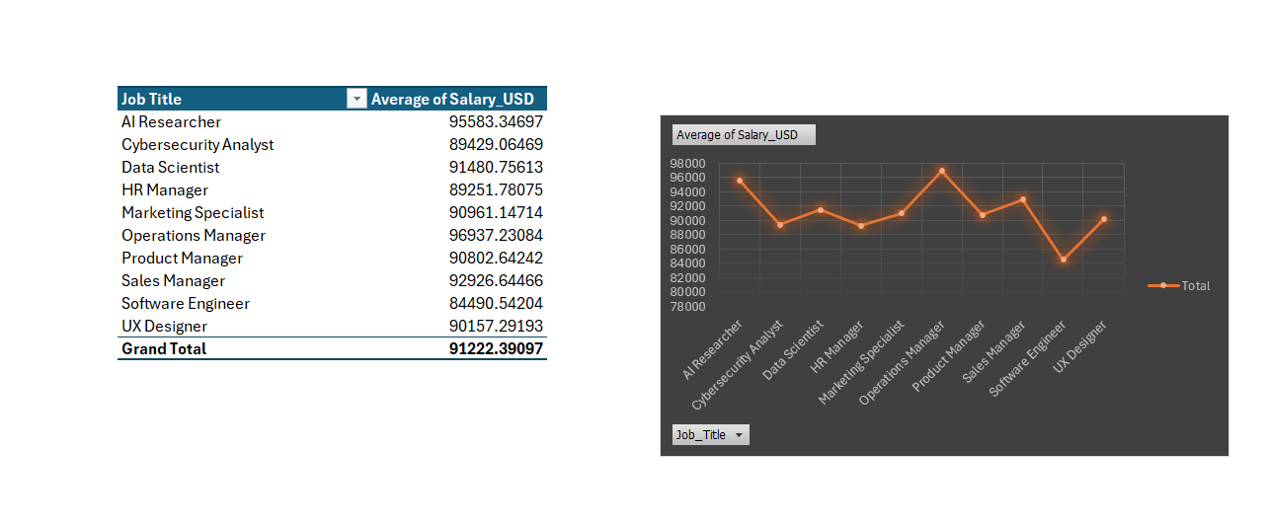

**Interpretation:**

Below is the interpretation of the pivot table showing the average salary-USD for different job titles.

**1. Average Salary by Job Title:**

* The pivot table shows the **average salary** (USD) for various job titles.
* **Operations Manager** has the **highest average salary** of about **$96,937**, closely followed by **AI Researcher** at around **$95,583**.
* **Software Engineer** has the **lowest average** salary at around **$84,490**.

2**. Trend Analysis from the Pivot Chart:**

* **Line chart** visualizes the average salary for each job title.
* **AI Researcher** starts high; there is a marked dip for **Cybersecurity Analyst**, then a slight recovery at **Data Scientist** and **HR Manager.**
* **Operations Manager**  peaked to show the **highest** salary among listed positions
* **Sales Manager** and **UX Designer** have **lower** dips, with particular reference to the very low end of **Software Engineer**.
* The chart ends with a small rise at **UX Designer**.

This could be helpful in understanding which job titles are superior in terms of finance, where there is room for salary advancement or at least negotiation.

**Job Growth Projections:**

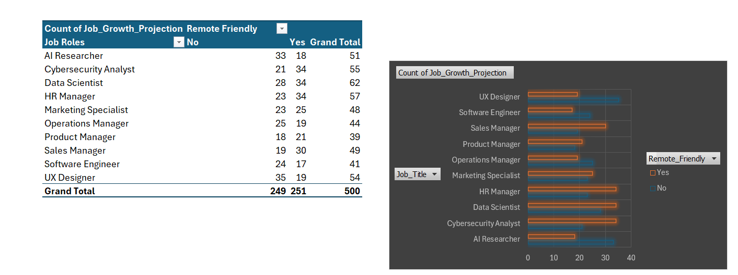

**Interpretation:**

1. **Projection of Job Growth by Remote-Friendly Status**:
   * This pivot provides an overview of job growth projection across a number of job titles, categorized into remote-friendly ("Yes") and non-remote-friendly ("No").
   * **Data Scientist** features **prominently** in both lists, with a slightly **higher** projection in the remote-friendly jobs at **34**
   * **UX Designer** tops the list in **non-remote-friendly**, at **35**, to show its preference for in-office work.
   * **HR Manager** is relatively **balanced** between **remote** and **non-remote-friendly** projections. The total for remote and non-remote-friendly is 57.
2. **Trend Analysis from the Bar Chart**:
   * The clustered - bar chart visualizes the job growth projection for each job title, split by remote-friendly and non-remote-friendly categories.
   * **AI Researcher** and **Cybersecurity Analyst** both represent a **steady** projection; **AI Researcher** **leans** more towards **non-remote-friendly**
   * **Operations Manager**  has a wide division where the projection is high for **non-remote-friendly jobs**.
   * While the growth of **Software Engineer** and **Sales Manager** are average, **Software Engineer** is a bit more open to being remote.
   * **UX Designer** has the highest projection that is **non-remote-friendly**, ending the chart with a notable preference for traditional settings.

The findings can provide insight into which job roles are more adaptable to remote work and where future growth lies in remote-friendly positions. It further shows those areas where non-remote roles remain in the majority and will inform their future workforce planning and job market strategies.

**DATA INTERPRETATION AND VISUALIZATION:**

**DATA INTERPRETATION:**

This Excel file comprehensively analyzes the AI job market, giving insights into demand, salary trends, and the skill sets required, along with any potential risks that may emanate from the assimilation of AI. Each sheet provides a different perspective on an ever-changing AI career landscape.

**AI Job Market Analysis:** The AI Job Market Analysis segmentalizes AI demand into sectors; the graph of leading industries and geographies regarding the growth of AI job roles portrays broader market trends.

**Summary Statistics:** The Summary Statistics tab presents a set of key indicators that underpin salaries, job openings, and demands for skills that help explain market trends and changes relevant for informed career choice.

**Broader Job Role Analysis:** The Broader Job Role Analysis tab digs deep into AI jobs in the broader context of job employment, how AI blends with traditional job roles, and changes across industries.

**AI Adoption Risks:** The AI Adoption Risks sheet is regarding the challenges of widespread AI use in things important to balance AI benefits with responsible implementations, including ethical concerns and job displacement.

**Skill Demand Analysis:** The Skill Demand Analysis sheet pinpoints the top-matching in-demand skills for AI roles and thus guides professionals on the most sought-after competencies reflective of the dynamism in the job market.

**Salary Trend Analysis:** The Salary Trend Analysis sheet examines changes in the compensation awarded for AI roles across time and geography, and represents one of the high opportunities in salary and changing trends in the emergent AI field.

**Job Growth Projections**: The Job Growth Projections sheet provides the growth rates for different AI roles and industries over the next few years to better pinpoint job opportunities on the rise and what to prepare for in the market.

**DATA VISUALIZATION**

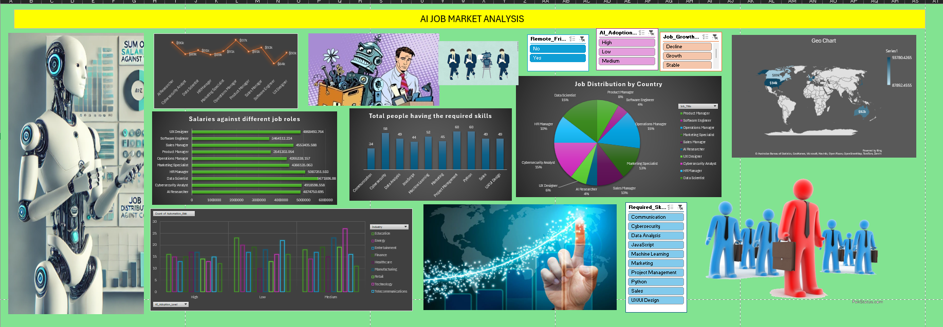

**After using slicers**

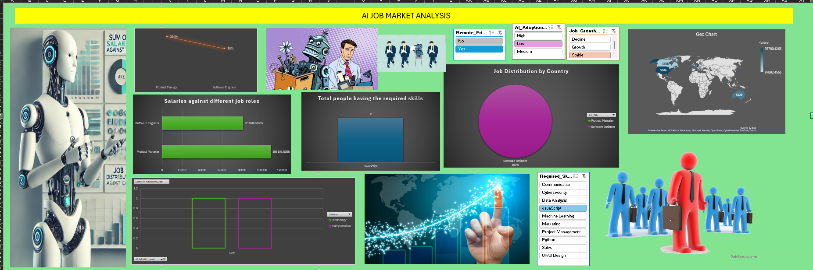

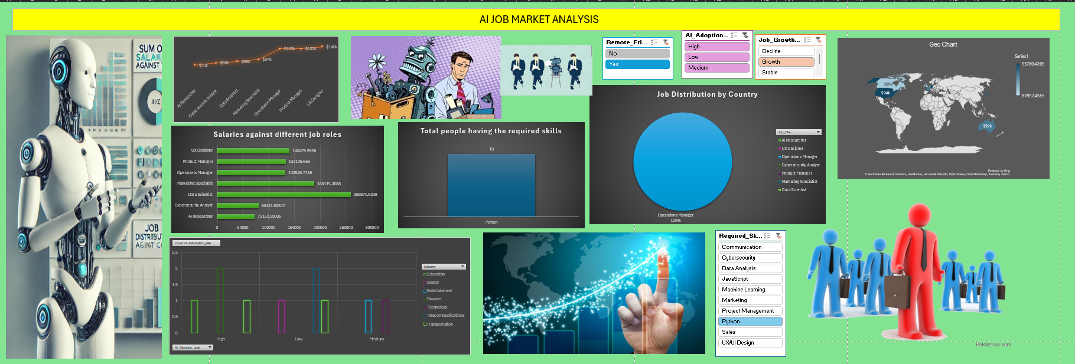

**DATA STORYTE LLING:**

The picture above is a detailed representation of the **AI job market**, with many data visualizations undertaking key messages that will be drawn from the results, including but not limited to:

1. **AI Skills and Job Roles:** Various bar graphs explain the **demand for AI skills** across different job roles. One can elaborate on the incremental trend of AI-related positions in this regard, whereby professionals possessing AI skills are more capable of receiving **better career opportunities with higher salaries.**

2. **Job Distribution by Country**: Job Distribution by Country through a pie chart, shows the exact **geographical distribution** of AI jobs in the world, underlining which regions **lead** in respect to AI job opportunities. The more extensive the share of some regions, like The U.S., the more this region is concerned with AI development and job creation.

3. **Salary Insights:** The rest of the graphs present a bar chart comparison of **salaries across job roles**, showing that AI roles boast competitive compensation, especially for senior levels.

4. **AI Adoption and Growth:** Another thing the infographic does is analyze the growth rate for AI adoption across industries and job categories, a measurement indicating which industries are leading the **AI revolution** and what skills are in greatest demand.

5. **Implication for AI Professionals:** The map thus indicates that regions investing more heavily in AI technologies and development offer more **financial incentives** to attract talent and therefore make them more attractive for **career growth** in AI.

The overall implication might be that **AI expertise** can imply a **competitive edge** with significant growth opportunities in many countries and industries..

**Recommendations:**

1. **Upskill Workforce**: One of the best ways a firm can fill its critical gaps in terms of employees would be upgrading employee skills, not just technically but also in non-technical areas such as artificial intelligence, effective communication, and project management.
2. **Leverage Remote Work:** Jobs will be remote-friendly, with a positive growth forecast, so companies should focus on improving their remote work policies to source the best talent from around the world while maintaining flexibility for jobs that will be performed along side AI.
3. **Investment in Key Sectors:** Focus on those industries with a high AI adoption rate where the risk of automation is low, for example, cybersecurity and AI research, which are very promising in terms of salary growth and job stability.
4. **Regional Strategies:** The companies have to create region-specific strategies for recruitment and create optimized compensation and strategies of talent acquisition, keeping the regional salary trends and niche AI talent availability in mind.

This should be useful for decision-makers across industries and geographies, seeking insights into AI workforce and salary policies.

**FINDINGS:**

**• Top Roles & Locations**: AI researchers and cybersecurity analysts are some of the most highly paid people, especially in San Francisco, London, and Singapore

• **Salary Trends:** The average salary trend stands at approximately $91,222 though it is higher in cities heavy with technology and those job position facing higher risks of automation.

• **Skill Demand:** UX/UI design, JavaScript, communication, and project management are highly sought-after skills.

• **Growth Projections:** Both the tech and cybersecurity industries have been growing rapidly with more increases in the remote-friendly jobs, while some other retail-oriented jobs have shown losses.

**References:**

The dataset was downloaded from **Kaggle,** one of the most popular online communities for data science and machine learning. This dataset forms the basis for the analysis of AI job roles, their salaried trends, and skill demand across industries and locations. This data set canbe downloaded from here:

[**https://www.kaggle.com/datasets/uom190346a/ai-powered-job-market-insights**](https://www.kaggle.com/datasets/uom190346a/ai-powered-job-market-insights)

**CONCLUSION**

**• Salary Discrepancies**: Salaries differ greatly with respect to location and size of the company. Large companies in tech hubs show competitive salaries.

• **Skill Gaps**: There is increasing demand for both technical and soft skills in AI job postings, especially in technologies that are at their budding stages and require expertise

• **Job Growth Potential**: A medium to high level of AI adoption in any industry is very likely to exhibit high job growth. However, sectors that run a high risk of automation may see more job losses or role changes.

**• Automation Risk Impact**: While jobs associated with higher automation risks draw links to higher salaries, it can be interpreted that inasmuch as there is a risk for such roles' automation, demand for them currently forces companies to give out relatively decent compensations with a view to attracting and sustaining talent. However, that again might mean that professionals in such roles need to reskill all the time.

• **Importance of Company Size**: Larger the company size, especially in the technology sector, higher will be the pay. This fact shows the more substantial resources larger firms can commit to recruiting top-notch AI talent and focus on innovation and automation within the premises of the larger organization.

• **Regional Competitiveness**: Cities such as Dubai, Berlin, and Tokyo have demonstrated lower levels of salary and mixed projections for job growth against other tech hubs like San Francisco and London. That indicates the continuing global job competitiveness in AI remains concentrated around key innovation hubs where demand for sophisticated AI competencies remains high.